**Cardiovascular Disease dataset** 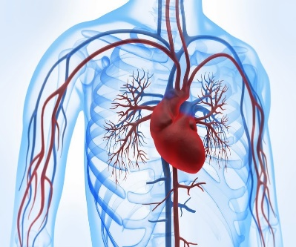

**Introduction:**

Heart and blood vessel disease (also called [heart disease](https://www.heart.org/en/health-topics/consumer-healthcare/what-is-cardiovascular-disease/coronary-artery-disease)) includes numerous problems, many of which are related to a process called [atherosclerosis](https://www.heart.org/en/health-topics/cholesterol/about-cholesterol/atherosclerosis).

Atherosclerosis is a condition that develops when a substance called plaque builds up in the walls of the arteries. This buildup narrows the arteries, making it harder for blood to flow through. If a blood clot forms, it can block the blood flow. This can cause a heart attack or stroke.

the cardiovascular disease dataset is an open-source dataset found on **Kaggle**

## **About The Dataset:**

The data was obtained from the kaggle website: [**https://www.kaggle.com/sulianova/cardiovascular-disease-dataset**](https://www.kaggle.com/sulianova/cardiovascular-disease-dataset)

# The dataset Contains 70000

Rows and 11 Columns:

* id: ID number
* age: in days
* gender: 1 - women, 2 - men
* height: cm
* wight: kg
* ap_hi: Systolic blood pressure
* ap_lo: Diastolic blood pressure
* cholesterol: 1: normal, 2: above normal, 3: well above normal
* gluc: 1: normal, 2: above normal, 3: well above normal
* smoke: whether patient smokes or not

The dataset is available as the .csv file. a sample of data is shown in the following table:

## صورة تحتوي على منضدة تم إنشاء الوصف تلقائياً

## **Tools:**

* There are tools that will be used to achieve the goal of this project, such as Jupyter notebook,Numpy,Matplotlib,pandas.

## **Questions This Project Will Answered:**

## what Number of people with heart disease smoking and non-smokers?

* what Number of people with heart disease?
* what Number of cholesterol?
* What Number of women and men?

**TO DO:**

* Explore the data and come up with EDA phases then use a model to fit the data.
* **NOTE:** the used features may be increased or changed and the model as well.